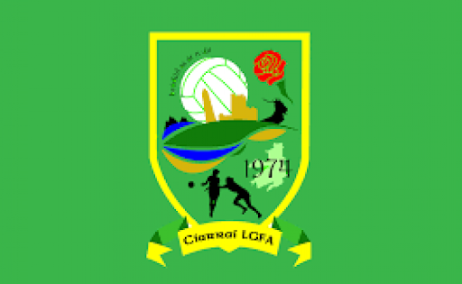
Kerry LGFA Schools Competition
Senior 2
- Pobalscoil Chorca Dhuibhne
- Pres Listowel
- Gaelcholáiste Chiarraí
- Tarbert
- Causeway
- Pres Castleisland

PCD – 4.24
A1
V
C1
B1
PCD
V
Gaelcholáiste
Pres Listowel
V
Loser A2
Pres Listowel – 1.4

A2
Cup Final
Gaelcholáiste
Winner C1
V
Winner C2
V
C2
Cisland CC
Pres Cisland
V
Causeway

Tarbert – 3.4
V
Causeway – 6.10

Pres Cisland
(bye)
A3
Pres Listowel
V
Tarbert

B2

Tarbert
V
Pres Cisland
Shield Final
A4

