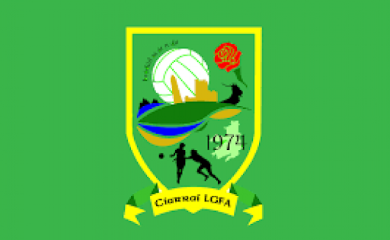
Kerry LGFA Schools Competition
First Year 2 – Group A
- Pres Tralee
- Pres Castleisland
- Kenmare
- Gaelcholáiste

Round 1
Gaelcholáiste 3.7 V Pres Cisland 7.9
Kenmare V Pres Tralee

*Cup Final = 1st Group A V 1st Group B* *Shield Final = 2nd Group A V 2nd Group B*

Round 2

Pres Cisland 5.12 V Pres Tralee 2.6

Gaelcholáiste V Kenmare

Round 3
Pres Tralee V Gaelcholáiste

Kenmare V Pres Cisland (April 27th)

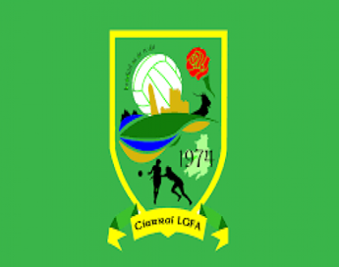
First Year 2 – Group A

Win = 3 points
Draw = 1 point
Loss = 0 points

Team | P | W | D | L | Pts
Pres Castleisland | 2 | 2 | 0 | 0 | 6
Kenmare | 1 | 1 | 0 | 0 | 3
Pres Tralee | 1 | 0 | 0 | 1 | 0
Gaelcholáiste | 1 | 0 | 0 | 1 | 0

